ER diagram

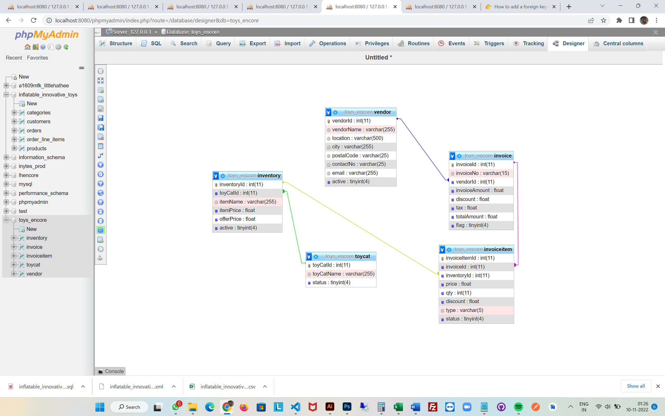

Use case :

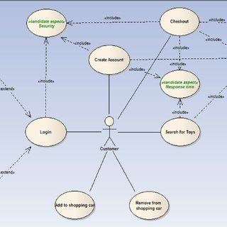

From the ER diagram it is clear that we are using the one to one relationship here for the process and we can also see that there is equal proportions of each modules from many to many and one to many relationships. The attribtes has the different sets of 0-1 relationship and 1-1 relationship. In order to best fit the data flow we can adjust the modelling parameters that can be taken apart from each side of the relationship and thus can be easy to ensure there is one to one and many to one.